1. .A ⊆ B 🡨🡪 { x ∈ A 🡪 x ∈ B}

So, C ⊆ D 🡨🡪 { x ∈ C 🡪 x ∈ D}

We want to show A x C ⊆ B x D.

So, (y, z) ∈ A x C 🡪 (y, z) ∈ B x D

(y, z) ∈ A x C implies that {y ∈ A} Λ {y ∈ C}

Which means {y ∈ B} Λ {y ∈ D} because A ⊆ B and C ⊆ D

Therefore, it’s proved that A x C ⊆ B x D

1. Venn Diagram of (B – A) ∪ (C – A)

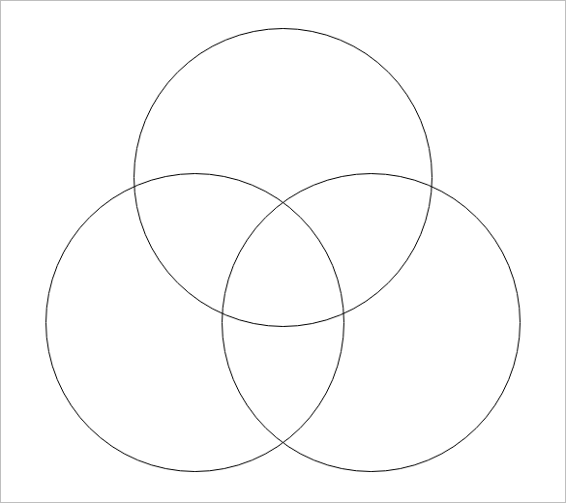

C

A

B

Venn Diagram for (B ∪ C) - A



C

B

A

1. (B – A) ∪ (C – A) = (B ∪ C) – A

Iff argument

Iff (B – A) ∪ (C – A)

Iff x ∈ (B – A) V x ∈ (C – A) Definition of Union

Iff (x ∈ B $∩$ x ∈ $\overline{A}$) V (x ∈ C $∩$ x ∈ $\overline{A}$) Definition of intersection

Iff (x ∈ B V x ∈ C) $∩$ x ∈ $\overline{A}$

Iff (x ∈ (B V C)) $∩$ x ∈ $\overline{A}$

Iff (B ∪ C) – A

Logical equivalences

(B ∪ C) – A

$$\left(B∪C\right)∩\overline{A}$$

$$\left(B∩\overline{A}\right)∩\left(C∩\overline{A}\right)$$

(B – A) ∪ (C – A)

1. (a) if A – C = B – C then A = B

A = {1, 2, 3}

B = {2, 3}

C = {1}

A – C = {2, 3}

B – C = {2, 3}

Therefore, the statement is wrong because A – C and B – C both share the same elements but A ≠ B.

(b) if A ∩ C = B ∩ C then A = B

A = {1, 2, 3}

B = {2, 3, 4}

C = {2, 3}

A ∩ C = {2, 3}

B ∩ C = {2, 3}

Therefore, the statement is wrong because A ∩ C and B ∩ C both share the same elements but A ≠ B.

1. Prove that if A − C = B − C and A ∩ C = B ∩ C then A = B.

To proof that A - C = B - C and A ∩ C = B ∩ C then A = B. Let A and B be sets.

Let’s try to prove that if $∈B$, then $x∈A$. We can assume that $x∈B$, and to conclude that $x∈A$. There are two cases now which are either $x∈C or x∉C$.

Case 1

If $x∈C$, we assume that $x∈B$, $x∈B∩C$. Since $A∩C=B∩C$ we can conclude that $x∈A∩C$. Hence $x∈A and x∈C$. Therefore, $x∈A$.

Case 2

If $x∉C$, we assume that $x∈B$, $x∈B-C$. Since $A-C=B-C$ we can conclude that $x∈A-C$. Hence $x∈A and x∉C$. Therefore, $x∈A$.

Both of these cases show that $x∈B→ x∈C$. Hence, $B⊆A$

Let’s assume the other way, if $x∈A$, then $x∈B$. With the two cases now, which are either $x∈C or x∉C$.

Case 1

If $x∈C$, we assume that $x∈A$, $x∈A∩C$. Since $A∩C=B∩C$ we can conclude that $x∈B∩C$. Hence $x∈B and x∈C$. Therefore, $x∈B$.

Case 2

If $x∉C$, we assume that $x∈A$, $x∈A-C$. Since $A-C=B-C$ we can conclude that $x∈B-C$. Hence $x∈B and x∉C$. Therefore, $x∈B$.

Both of these cases show that $x∈A→ x∈B$. Hence, $A⊆B$

We have shown that $A=B$, by the definition of equivalency which is If $x∈B→ x∈C$ . (This proves $B⊆A$ ). If $x∈A→ x∈B$ . (This proves $A⊆B$).

$\overline{A∪B}=\overline{A}∩\overline{B}$

$$A∪\left(B∩C\right)=\left(A∪B\right)∩ \left(A∪C\right)$$

$$Assume ∃x\left(B∩C\right)$$

$$=x∈A V (x∈B Λ x∈C)$$

$$=\left(x∈A V x∈B\right) Λ\left(x∈A V x∈C\right)$$

$$= x∈\left(A V B\right) Λ x∈\left(A V C\right)$$

$$=x∈\left(A ∪ B\right) ∩ x∈\left(A ∪ C\right)$$

$$= x∈ A ∪\left(B ∩ C\right)$$

$=A∪\left(B∩C\right)⊆\left(A∪B\right)∩\left(A∪C\right)$ (1)

$$Assume ∃x\left(\left(A∪B\right)∩\left(A∪C\right)\right)$$

$$=x∈\left(A∪B\right)∩\left(A∪C\right)$$

$$=x∈\left(A V B\right) Λ x∈\left(A V C\right)$$

$$=\left(\left(x∈A\right) V \left(x∈B\right)\right)Λ \left(\left(x∈A\right)V \left(x∈C\right)\right)$$

$$=\left( x∈A\right) V \left(x∈B Λ C\right)$$

$$=\left( x∈A\right) ∪ \left(x∈B ∩ C\right)$$

$$=x∈\left(A ∪\left(B ∩ C\right)\right)$$

$$=x∈\left(A∪B\right)∩\left(A∪C\right)$$

$=\left(A∪B\right)∩\left(A∪C\right) ⊆ \left(A ∪\left(B ∩ C\right)\right)$ (2)

$= A∪\left(B∩C\right)⊆\left(A∪B\right)∩\left(A∪C\right)$ (1) (2)

$$\overline{A∪B}=\overline{A}∩\overline{B}$$

Q.E.D

1. f: Z+ 🡪 Z+

f(n) = 5n + 12

f(y) = 5y + 12

f(n) = f(y)

5n + 12 = 5y + 12

5n = 5y

n = y

Therefore, it is one-to-one

f(n) = 5n + 12

Let 5n + 12 = 0

5n = -12

n = $-\frac{12}{5}$

Therefore, f is not onto because domain and co-domain supposed to be positive integers and n is not positive nor integer in this case.

1. f(m, n) = 3mn for f: R x R 🡪 R

$$a=3mn$$

$$m=\frac{a}{3n}$$

$$a=3\left(\frac{a}{3n}\right)n$$

$$a=a$$

Therefore, it is onto because inverse of it gives 1 value only

f(m, n) = 3mn

f(-2, -2) = 3(-2)(-2) = 12

f(2, 2) = 3(2)(2) = 12

f(-2, -2) and f(2, 2) both have different values of m and n but both the equations have the same result. There, it is not one-to-one.